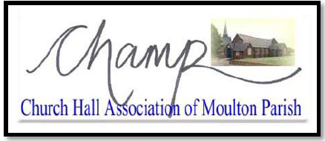

Bar staff Guide for the provision of alcohol at Moulton Church Hall

It is against the law:
- To sell alcohol to someone under 18 anywhere, and can lead to a maximum fine of £20,000 for bar staff/managers or premises may eventually be shut down.
- For an adult to buy or attempt to buy alcohol on behalf of someone under 18.
- For someone under 18 to buy alcohol, attempt to buy alcohol or to be sold alcohol.

Bar Staff can reserve the right to:
- Refuse the sale of alcohol to an adult if they’re accompanied by a child (under 18) and think the alcohol is being bought for the child.

ID for alcohol: proving your age - Acceptable forms of ID to prove to you are over 18 are:
- a photo driving licence
- a passport
- a proof of age card, such as the PASS card from the national Proof of Age Standards Scheme.

It’s a criminal offence to use false or borrowed ID to gain entry to licensed premises or to buy alcohol. The maximum penalty is a £5,000 fine and up to 10 years in prison.

Challenge 25
Challenge 25 is a scheme that encourages anyone who is over 18 but looks under 25 to carry acceptable ID when they want to buy alcohol. Challenge 25 builds on the Challenge 21 campaign introduced by the British Beer and Pub Association, who represent the beer and pub sector, in 2005. It’s now run by the Retail of Alcohol Standards Group, which represents alcohol retailers.
Incident report
If you have reason to refuse service of alcohol, or experience any undue challenges or unreasonable behaviour that result in you refusing to serve alcohol, you are required to record this in as much detail as possible in the incident log that will be available on the premises during the licenced event.

By signing this form, you are agreeing to these terms and conditions of service.

For more information on serving alcohol, visit The law and under 18s page and the 'Licensing Act 2003' government page.

