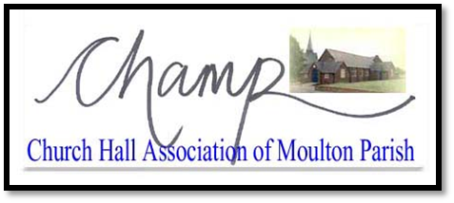 | MOULTON VILLAGE HALL  BOOKING FORM
BOOKING SECRETARY: Stephen Allen_Gurr
Email: sjbmgurr@btinternet.com

Hirer |  | Tel: |  | Mob:
Address
Email
Description of Function
Day(s)/Date(s)
Times ¹ | From: |  | To:
( ¹ NB – No bookings to continue after MIDNIGHT)
Name of Caterer
Address of Caterer
Do you require a Licensed Bar? (please check appropriate box) ² |  | Yes | No
( ² NB – Alcohol can only be sold with authorisation of the Management Committee-conditions apply)
CHARGES PAYABLE
FOR OFFICE USE ONLY | £ |  | Please make cheques payable to the  Church Hall Association of Moulton Parish
Main Hall
Charge for Bar Facilities
Back Hall |  |  | ³ Indemnity is refundable
Meeting Room
Indemnity ³ |  |  | ⁴ Bookings cannot be accepted until full fee has been paid, and not less than 48 hrs before proposed event
TOTAL AMOUNT DUE ⁴
(Please make cheques payable to Church Hall Association of Moulton Parish)
I / We make this booking in full knowledge and acceptance of the Booking and Hire Conditions (attached), and am / are over 18 years of age.
SIGNED: _______________________________ DATE: _______________________

Accepted on behalf of CHAMP the sum of £ __________ Payment Details: ____________________
SIGNED: _______________________________ DATE: _______________________

